Lakshyagriha 4.0 Hackthon Problem 1 solutions
Problem 1:
USE rarebooks;

SELECT
cc.condition_description,
COUNT(v.inventory_id) AS count
FROM
Volume v
JOIN
Condition_Codes cc ON v.condition_code = cc.condition_code
WHERE
v.sale_id IS NULL
GROUP BY
cc.condition_description
ORDER BY
cc.condition_description;

Output:
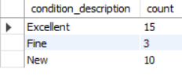

Problem 2:
USE rarebooks;

SELECT
cc.condition_description,
SUM(v.selling_price) AS total_sales
FROM
Volume v
JOIN
Condition_Codes cc ON v.condition_code = cc.condition_code
JOIN
Sale s ON v.sale_id = s.sale_id
WHERE
v.selling_price IS NOT NULL
GROUP BY
cc.condition_description
ORDER BY
total_sales DESC;

Output:
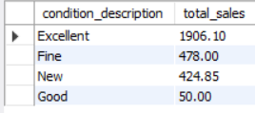

Problem 3:

USE rarebooks;

SELECT
a.author_last_first AS author,
w.title,
COUNT(v.inventory_id) AS count
FROM
Volume v
JOIN
Book b ON v.ISBN = b.ISBN
JOIN
Work w ON b.work_numb = w.work_numb
JOIN
Author a ON w.author_numb = a.author_numb
WHERE
v.sale_id IS NULL
GROUP BY
a.author_last_first,
w.title
ORDER BY
author,
title;

Output:
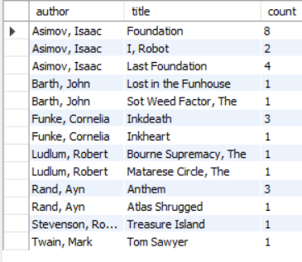

Problem 4 :
USE rarebooks;

SELECT
b.ISBN,
w.title,
p.publisher_name,
b.edition,
b.binding,
b.copyright_year,
COUNT(v.inventory_id) AS count
FROM
Volume v
JOIN
Book b ON v.ISBN = b.ISBN
JOIN
Work w ON b.work_numb = w.work_numb
JOIN
Publisher p ON b.publisher_id = p.publisher_id
WHERE
v.sale_id IS NULL
GROUP BY
b.ISBN,
w.title,
p.publisher_name,
b.edition,
b.binding,
b.copyright_year
ORDER BY
p.publisher_name;
Output :
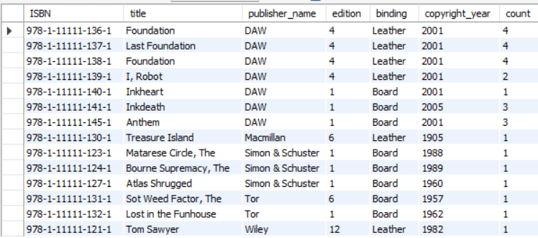

Problem 5:
SELECT
YEAR(s.sale_date) AS year,
MONTH(s.sale_date) AS month,
DAY(s.sale_date) AS day,
SUM(s.sale_total_amt) AS sales
FROM
Sale s
WHERE
YEAR(s.sale_date) = 2021
GROUP BY
YEAR(s.sale_date),
MONTH(s.sale_date),
DAY(s.sale_date) WITH ROLLUP
HAVING
year IS NOT NULL;
Output:
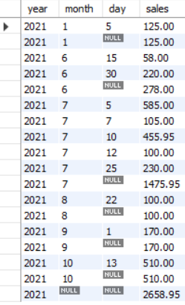
Problem 6:
SELECT
v.inventory_id,
w.title,
cc.condition_description,
v.selling_price
FROM
Volume v
JOIN
Book b ON v.ISBN = b.ISBN
JOIN
Work w ON b.work_numb = w.work_numb
JOIN
Condition_Codes cc ON v.condition_code = cc.condition_code
JOIN
Sale s ON v.sale_id = s.sale_id
WHERE
v.selling_price > (
SELECT AVG(v2.selling_price)
FROM Volume v2
JOIN Sale s2 ON v2.sale_id = s2.sale_id
WHERE MONTH(s2.sale_date) = 7 AND YEAR(s2.sale_date) = 2021
)
ORDER BY
w.title;
Output:
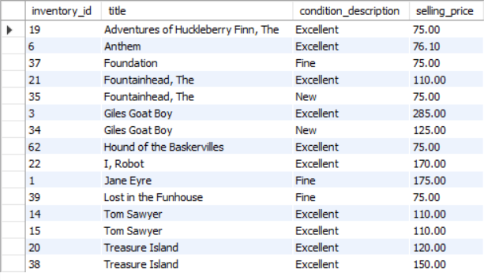
Problem 7:
SELECT
a.author_last_first AS author,
w.title,
COUNT(v.inventory_id) AS copies_sold,
SUM(v.selling_price) AS total_sales
FROM
Volume v
JOIN
Book b ON v.ISBN = b.ISBN
JOIN
Work w ON b.work_numb = w.work_numb
JOIN
Author a ON w.author_numb = a.author_numb
JOIN
Sale s ON v.sale_id = s.sale_id
WHERE
MONTH(s.sale_date) = 7 AND YEAR(s.sale_date) = 2021
GROUP BY
a.author_last_first,
w.title
ORDER BY
copies_sold DESC;
Output:
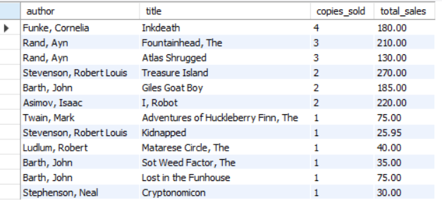
Problem 8:
INSERT INTO Sale (customer_numb, sale_date, sale_total_amt, credit_card_numb, exp_month, exp_year)
VALUES (3, '2021-11-03', 125.00, '1234 5678 9101 4321', 7, 23);

SET @last_sale_id = LAST_INSERT_ID();

UPDATE Volume
SET sale_id = @last_sale_id, selling_price = 125.00
WHERE inventory_id = 67;
Problem 9:
INSERT INTO Publisher (publisher_name) VALUES ('Thorndike Press');

INSERT INTO Author (author_last_first) VALUES ('Rowling, JK');

INSERT INTO Work (author_numb, title)
VALUES ((SELECT author_numb FROM Author WHERE author_last_first = 'Rowling, JK'), 'Harry Potter and Sorcerer''s Stone');

INSERT INTO Book (ISBN, work_numb, publisher_id, edition, binding, copyright_year)
VALUES ('978-0-78622-272-8',
(SELECT work_numb FROM Work WHERE title = 'Harry Potter and Sorcerer''s Stone'),
(SELECT publisher_id FROM Publisher WHERE publisher_name = 'Thorndike Press'),
1, 'Leather', '1999');

INSERT INTO Volume (ISBN, condition_code, date_acquired, asking_price, selling_price, sale_id)
VALUES ('978-0-78622-272-8',
(SELECT condition_code FROM Condition_Codes WHERE condition_description = 'Excellent'),
'2018-03-01', 100.00, NULL, NULL);

Problem 10:
USE rarebooks;

-- Delete volumes associated with Thorndike Press
DELETE v
FROM Volume v
JOIN Book b ON v.ISBN = b.ISBN
JOIN Publisher p ON b.publisher_id = p.publisher_id
WHERE p.publisher_name = 'Thorndike Press';

-- Delete books associated with Thorndike Press
DELETE b
FROM Book b
JOIN Publisher p ON b.publisher_id = p.publisher_id
WHERE p.publisher_name = 'Thorndike Press';

-- Delete the publisher
DELETE FROM Publisher
WHERE publisher_name = 'Thorndike Press';

